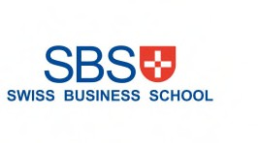

PUBLICATIONS OF TRANSCRIPTS AND DEGREES CONFIDENTIALITY AGREEMENT

Students are **neither allowed nor permitted** to post on **any social media platform images** of their own academic transcripts or degrees.

SBS has the right to take legal action against any student, who has agreed and signed the foreseen agreement but still posts any academic material such as degrees or transcripts online.

In such case, rescinding a degree will be considered as the next call of action.

The student agrees not to disclose any sensitive information about academic degrees or transcripts at any time on social media platforms, such as Facebook, LinkedIn, etc. The students is not allowed to share the degrees and transcripts publicly. The student is permitted to upload the degrees and transcripts on employment and career platforms, only if it is not public for all users (only to the potential employer). Uploading the diploma cover or thesis cover is allowed.

The above-mentioned information is not permitted to be disclosed to any third parties.

I, Wassim Hassan Outhman (First/Last name), understand that the failure to abide by the stated given terms of SBS “publications of transcripts and degrees confidentiality agreement” may result in the termination of my academic studies and revoke of the degree.

I, Wassim Hassan Outhman (First/Last name), have read the above terms of SBS “publications of transcripts and degrees confidentiality agreement” and fully comply with the terms as part of my student responsibilities.

**Signature of Student Date**

**Wassim Hassan Outhman October 12, 2023**